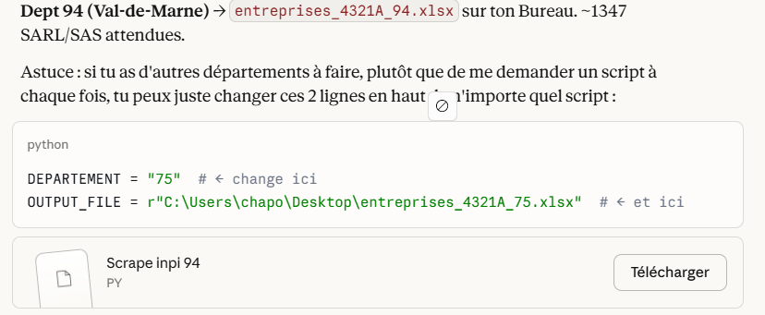

Juste à changer dans le script en fonction du département souhaité
Sur ce site :
https://data.inpi.fr/search?advancedSearch=%257B%2522checkboxes%2522%253A%257B%2522status%2522%253A%257B%2522order%2522%253A0%252C%2522searchField%2522%253A%255B%2522is_rad%2522%255D%252C%2522values%2522%253A%255B%257B%2522value%2522%253A%2522false%2522%252C%2522checked%2522%253Atrue%257D%252C%257B%2522value%2522%253A%2522true%2522%252C%2522checked%2522%253Afalse%257D%255D%257D%257D%252C%2522texts%2522%253A%257B%2522ape%2522%253A%257B%2522order%2522%253A7%252C%2522searchField%2522%253A%255B%2522formality.content.personnePhysique.etablissementPrincipal.activites.codeApe%2522%252C%2522formality.content.personneMorale.etablissementPrincipal.activites.codeApe%2522%255D%252C%2522checkedSearchField%2522%253A%255B%255D%252C%2522value%2522%253A%25224321a%2522%257D%257D%252C%2522multipleSelects%2522%253A%257B%2522state%2522%253A%257B%2522order%2522%253A11%252C%2522searchField%2522%253A%255B%2522formality.content.personneMorale.etablissementPrincipal.adresse.codePostalShort%2522%252C%2522formality.content.personnePhysique.etablissementPrincipal.adresse.codePostalShort%2522%252C%2522formality.content.personneMorale.autresEtablissements.adresse.codePostalShort%2522%252C%2522formality.content.personnePhysique.autresEtablissements.adresse.codePostalShort%2522%255D%252C%2522value%2522%253A%255B%257B%2522value%2522%253A%252294%2522%252C%2522label%2522%253A%252294%2522%252C%2522parents%2522%253A%255B%255D%252C%2522isFolded%2522%253Atrue%252C%2522isLastChild%2522%253Atrue%257D%255D%257D%257D%252C%2522dates%2522%253A%257B%257D%257D&displayStyle=List&filter=%257B%2522idt_pm_code_form_jur%2522%253A%255B%25225710%2522%252C%25225499%2522%255D%252C%2522idt_cp_short%2522%253A%255B%252294%2522%255D%257D&nbResultsPerPage=20&order=asc&page=1&q=&searchType=advanced&sort=relevance&type=companies

